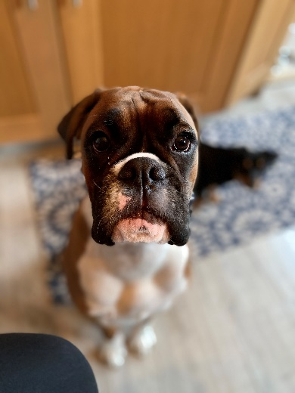

Add or Change, to make this relevant to your fur family
Pet Name:
Breed:
Health: I am fully vaccinated, and I have worming and flea treatment every 6-8 weeks. I have regular visits to the groomers, so I am always a clean girl who smells nice. I have just travelled from England and have had a full testing and vaccination along with a quarantine period to become an Australian
Temperament: Loving, good with other dogs, good with adults and children.
About me: I am a boxer so will always be young at heart. I am friendly and love attention. I am still young at 20 months, but I am very clever and fully trained as my owners enrolled me in classes as soon as they brought me home as an 8-week-old puppy.
I love being outside going for walks and going to our local field to play with all my other dog friends where we run about chasing a ball.
When I’m not in the field I do like to sleep a lot at home. I get on well with my neighbors who like to stroke me over the gate. They always say I am a good girl.

About my owners: My mum & dad love me very much and take me out for regular exercise. My mum has also taken courses on dog ownership so my training will continue in the home.

References attached:

This Photo by Unknown Author is licensed under CC BY-NC-ND

